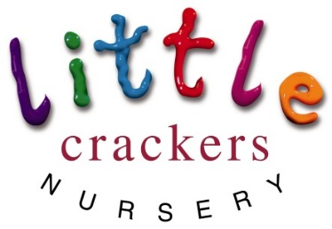
Weekly News

10th May 2019

Nursery notices:  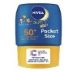  My apologies everyone!  I metioned the ‘suncream/hat’ rule…  So… it has been cold and wet ever since!!!!!  Please be prepared however…  Light layers, named hats, suncream – just in case!  Message from Mrs Bird:  To parents of the pre-school children,  Please can you let her know as soon as possible when your child’s last day in nursery will be so that the billing  can be accurately calculated.  Thank you x |  | Dates to remember:  Half term (term time children)  Mon 27th May-Mon 3rd June  SPORTS DAY!!!  Thursday 13th June 9.30am  PRE-SCHOOL GRADUATION!!!  Tuesday 25th June (afternoon)  School closes for the Summer  (term time children)  Wednesday 3rd July
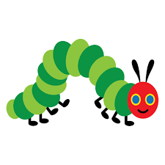
Joke of the week:  What do you get if you cross an elephant with a fish?  +=  Swimming trunks!!! | Caterpillar Watch…  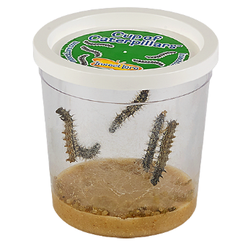  We have 5 curly caterpillars!! |  | Don’t forget the Family Fun Day…  This Saturday  Crackley Hall 1pm  Come and have your face painted!!!!!
Little Crackers Nursery · Crackley Hall · St Joseph’s Park · Kenilworth · CV8 2FT
Telephone: 01926 514444 · Fax: 01926 514455 · e-mail: littlecrackers@crackleyhall.co.uk
www.crackleyhall.co.uk

Registered Charity Number 1087124 Company limited by guarantee Number 4177718

You can email Mrs Bird clarebird@crackleyhall.co.uk
or ring the nursery direct 01926 514456

